Information memorandum
JSC "Pinsky zavod sredstv maloy mechanizatsii"

1. General information about the company (short description)

Full name of the company | Open Joint Stock Company  «Pinsky zavod sredstv maloy mechanizatsii»
Industry | Machine building
Date of foundation | 01.01.1986
Shareholders | Pinsk City Executive Committee,  "Amcodor-Centr" LLC
Company location and website | 225710, Republic of Belarus, Pinsk, Brest Region,  17 Kozubovsky str.  pinsksmm.by

2. Company activity and output products
1) Main and other types of activities (their share in the total revenues, in %)
The main activities of OJSC SMM are:
- designing, manufacturing, repair and diagnostics of lifting equipment (hydraulic lifts) , handling equipment (loaders);
- production of construction, road and earth-moving machinery;
- manufacture of rubber products;
- production of other means of mechanization (military products).
.The share of output of certain types of products in 2023 in the total volume of products is:
- hydraulic lifts – 52.2%;
- military products – 22.4%;
- other products – 25,4%.

2) Description of products
Name of products | Characteristics | Photo
High-strength steel hydraulic elevators | Lifting height - 18 m  Carrycot carrying capacity - 250 kg | 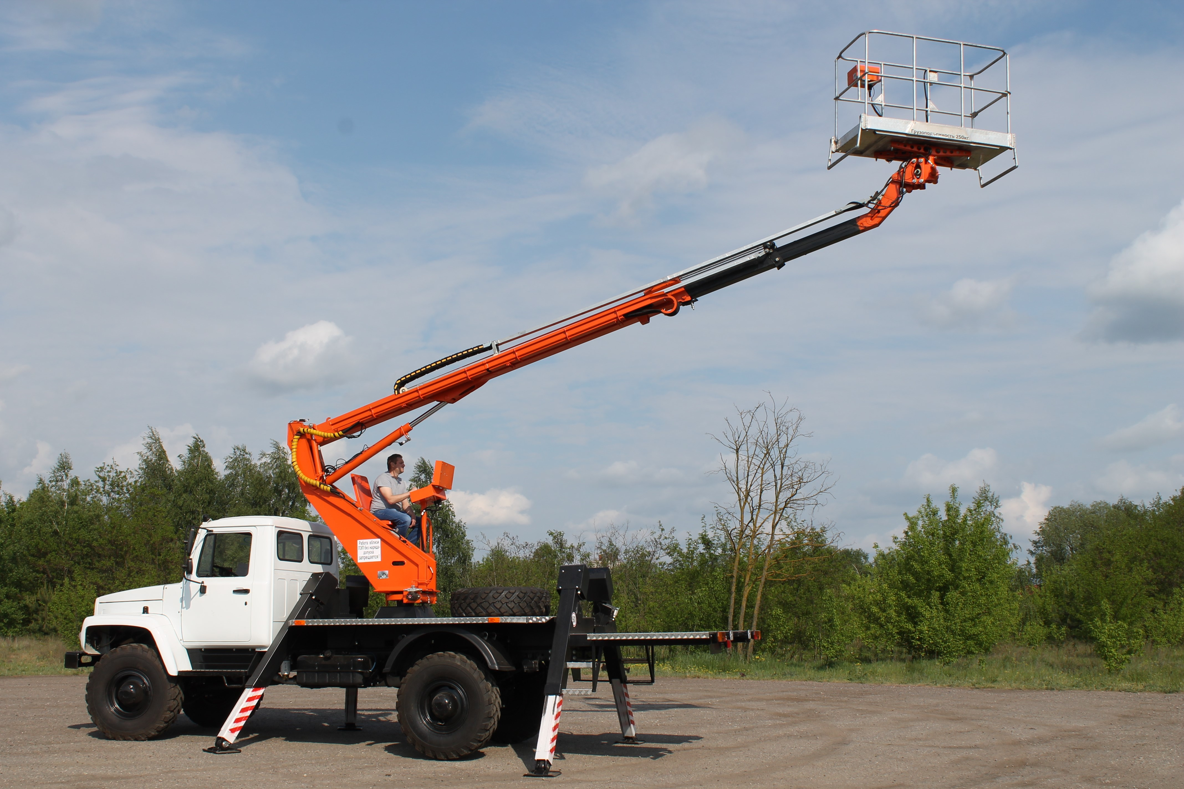
Articulated hydraulic elevators | Lifting height - 28 m  Carrycot carrying capacity - 250 kg | 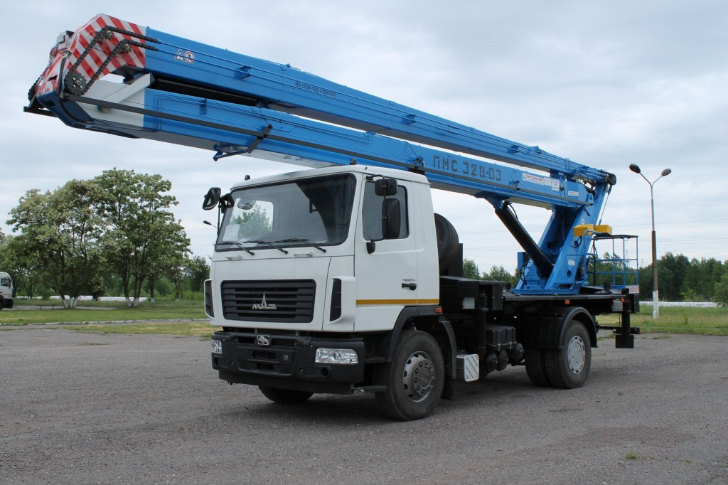
Telescopic hydraulic elevators | Lifting height - 18 m  Carrycot carrying capacity - 250 kg | 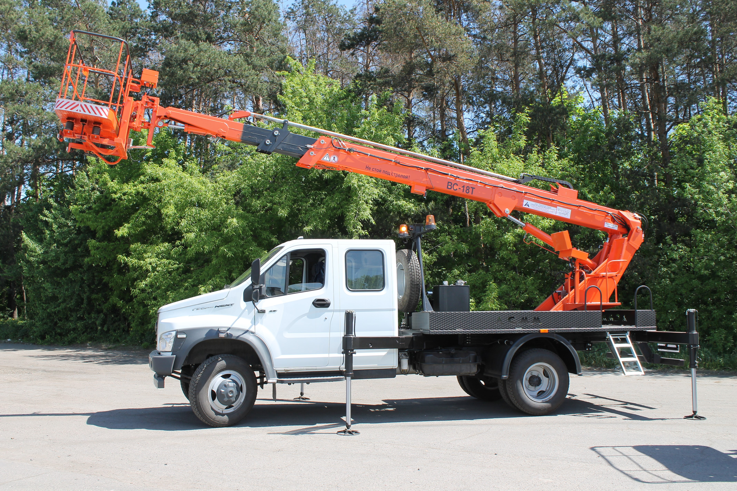
Articulated telescopic hydraulic lift | Lifting height - 22 m  Carrycot carrying capacity - 250 kg | 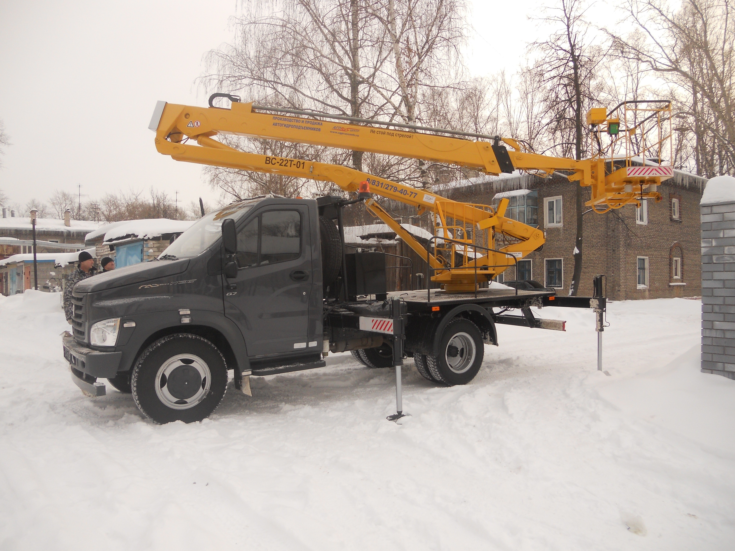
Telescopic loader PT-3010 | Lift height – 9,9 m  Carrying capacity - 3000 kg | 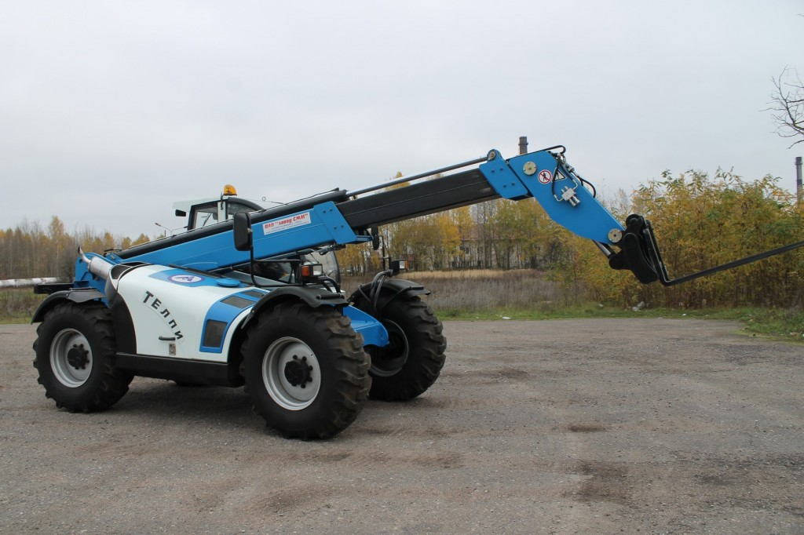
Excavators | Loading capacity of loading equipment - 1000 kg  Bucket capacity - 0.28 m³ | 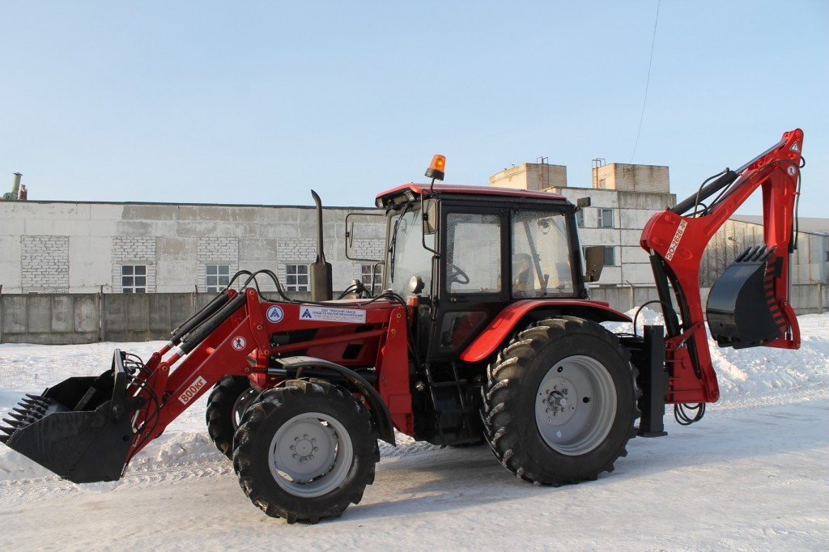
3) Company’s production capacities

Products, works, services (by types) | Issue volume | Year
 |  | 2021 | 2022 | 2023
Hydraulic lifts | pcs. | 81 | 49 | 36
Excavators | pcs. | 24 | 3 | 0
High-pressure hoses | pcs. | 116 | 204 | 0
Military products | thousand USD | 535 | 0,203 | 1,72

4) Characteristics of existing social obligations in the company, including medical and pension expenses for retired employees.

Types of social obligations | Characteristic
Additional compensation, guarantees and employee benefits | Provide financial assistance for health leave; 1 time a year to register a vehicle with a 50% discount; authorize the use of a car lift for the repair of personal vehicles once every 6 months; organize recreation of the children of the Company's employees in health camps, send war veterans annually congratulations on Victory Day with the presentation of gifts or cash bonuses in the amount of up to 2 base units; to reward employees for the professional holiday Machine Builder's Day, to pay for voluntary medical insurance of the Company's employees.  .

3. Characteristics markets
1) JSC "Pinsky zavod sredstv maloy mechanizatsii" exports its products (up to 64%) to Russia, Kazakhstan, Azerbaijan and to the republics of Central Asia. There is a dealer network in the abovementioned countries: Russia, Kazakhstan, Azerbaijan.

2) The structure of the product sales (works, services), %

Name of products | 2021 | 2022 | 2023
Internal market | 36 | 49,3 | 62,6
External market | 64 | 50,7 | 37,4
Total | 100 | 100 | 100

3) Main competitors (manufacturers of products (works, services) with similar consumer properties)
The main competitor of the enterprise is the Private Enterprise Machine-Building Company «Vitebsk Lifts».

4. Labor resources on 01.01.2024
1) Average number of employees, people -189
2) Average monthly wage (in rubles and US dollars) – 1217,9 BYN (405,8 $)

5. Financial indicators of the company’s business activity (thousand USD)

1) Selected indicators of the balance sheet

Balance, thousand USD | 31.12.2021 | 31.12.2022 | 31.12.2023
Fixed assets | 3074,77 | 3472,55 | 3224
Total long-term assets | 3097,23 | 3484,10 | 3247
Stocks | 1699,50 | 1842,06 | 1710
Trade and other receivables | 389,22 | 468,34 | 204
Total short-term assets | 2604,40 | 2938,28 | 2277
TOTAL ASSETS | 5701,62 | 6422,38 | 5524
Total equity | 5286,79 | 5763,58 | 5104
Total long-term liabilities | 0 | 0 | 0
Loans | 117,79 | 54,96 | 3
Trade and other payables | 297,04 | 603,84 | 416
Total short-term liabilities | 414,83 | 658,80 | 419
Total liabilities | 414,83 | 658,80 | 419
TOTAL LIABILITIES SIDE | 5701,62 | 6422,38 | 5524

2) Selected data of profit and loss account

Profit and loss account,  thousand USD | 2021 | 2022 | 2023
Revenue | 3103,14 | 3101,26 | 3110,42
Self-cost | 2172,63 | 2119,55 | 1950,55
Gross profit | 930,51 | 981,71 | 1159,87
Operating profit | -118,58 | -31,68 | -211,91
Financial expenses | 359,28 | 665,29 | 10,66
Profit before tax | -174,13 | 11,45 | -221,24
Income tax expense | 0 | 0 | 0
Net profit/loss | -152,46 | 3,05 | -221,24
EBITDA (earnings before interest, taxation, depreciation and amortisation) | 46,63 | 175,44 | -2,33
Net profit margin,% | -4,91 | 0,1 | -7,1
Additional financial indicators
Net asset value | 5286,79 | 5763,58 | 5104,29
Dividends on shares owned by the Republic of Belarus | 0 | 0 | 0

3) Indicators of the company's solvency
Solvency ratios | Coefficient value  on 31.12.2023 | Normative value
current liquidity ratio (K1) | 5,47 | >1.3
working capital adequacy ratio (K2) | 0,82 | >0.2
current liabilities to assets ratio (K3) | 0,08 | ≤0.85

6. Information about the investment activities of company

1) Implemented (or implemented over the last 3 years) investment projects with an indication of their value, the volume of utilized investments, information about the introduced new technologies, equipment, increase in production volumes, expansion of the range, etc., provided by the introduction of new technologies and equipment.

Name of equipment, projects, technologies | Year of implem. | Volume of investments, $.
Mobile dot marking machine | 2022 | 8584
Drying cabinet | 2022 | 481
Induction Heating Installation | 2023 | 18 167
Hardening furnace | 2023 | 25 940

2) Investment projects planned for implementation (name of projects, total cost of each, sources of financing, expected effect)

The planned investment projects in 2024
Name of equipment | Cost, $
Horizontal Machining Center | 600 000
Lathe horizontal machining center | 133 333
Vertical milling machining center | 150 000

7. Information on land plots in use, lease
Location  plot | Right to use the  land plot  (permanent, temporary and lease – with indication of the period ) | Land area (ha), cadastral number | Cadastral value of the land plot,  USD as of the date of prices
225710, Republic of Belarus, Pinsk, Brest Region,  17 Kozubovsky str. | permanent use | 9,0076 ha,  №144500000006000029 | 1 381 766

8. Information on capital structures (buildings, facilities) and isolated premises (add photos)

Photo | Name (purpose),  location | Year  the buildings | Area, m² | Square,  leased (m²),  lease term
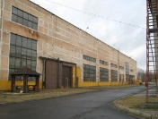 | Industrial building  Pinsk, Kozubovsky str., 17  Certificate No. 130 / 218-5078 dated August 23, 2010 | 1985 | 23130,5
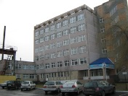 | Administrative building  Pinsk, Kozubovsky str., 17 | 1985 | 4818
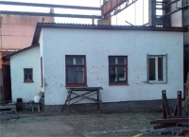 | Metal warehouse workers’ cabins  Pinsk, Kozubovsky str., 17  Certificate No. 130 / 917-2563 dated December 23, 2009 | 2001 | 23,6
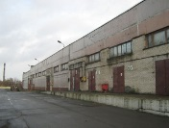 | Central warehouse  Pinsk, Kozubovsky str., 17 | 1986 | 2710
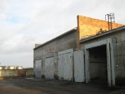 | Garage  Pinsk, Kozubovsky str., 17 | 1988 | 850
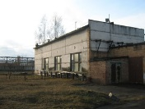 | Block of auxiliary premises  Pinsk, Kozubovsky str., 17 | 1985 | 210
9. Licensing and approvals in the industry, intellectual property rights

In the JSC " Pinsky zavod sredstv maloy mechanizatsii " developed, implemented and operates a quality management system for the design, development and production of hydraulic lifts and excavators in accordance with the requirements of STB ISO 9001-2015 dated 20.06.2008. There is a certificate No. BY / 11205.01.016 6200010 dated June 25, 2021, valid until June 24, 2024.
JSC " Pinsky zavod sredstv maloy mechanizatsii " has developed, implemented and certified OSH management systems. There is a certificate No. BY112 05.04.091. 01 00461 , valid until January 16, 2025, which certifies that the health and safety management system in professional activities (labor protection management) of the production of hydraulic elevators and excavators meets the requirements of STB ISO 45001-2020.
JSC " Pinsky zavod sredstv maloy mechanizatsii " issued the following patents:
- patent No. 1064 for a trailer lift with a trunk of a pantograph type, beginning from December 31, 2004;
- patent No. 1065 for a hydraulic lift mounted on chassis GAZ-3302, the start date of the action is -24.03.2005;
- patent No. 1066 for a hydraulic lift mounted on chassis MAZ-5337, the date of the beginning of the action - 12.09.2005;
- patent No. 1067 for a hydraulic lift mounted on chassis ZIL 5301BO, the date of the beginning of the action is 12.09.2005.
The following special permits (licenses) are in effect at JSC "Pinsky zavod sredstv maloy mechanizatsii":
- License for the right to carry out activities to ensure the security of legal entities and individuals No. 02010/4647;
- License for the right to carry out activities in the field of road, inland waterway, maritime transport (excluding intra-republican transportation for own needs) No. 02190/2-17857;
- License for the right to carry out activities in the field of industrial safety No. 33133/2397-1 with amendments and additions dated March 20, 2017;
- License for the right to carry out activities related to military products.

10. Contact information

Legal address | 225710, Republic of Belarus, Pinsk, Brest Region, 17 Kozubovsky str.
Supervisor | Savchenko Aleksandr Mikhailovich
Contact phones / fax | 8-0165-37-14-82
E-mail | smm@pinsksmm.by, smm05@mail.ru
Web-site | pinsksmm.by

